HSI

LED String:

Revision History Table:

|  |  |  |  |
| --- | --- | --- | --- |
| Version | Author | Date | Status |
| 1.0 | Caroline Youssef / Mahmoud Gamal | 23/1/2020 | Initial Creation |
| 1.0.1 | Caroline Youssef / Mahmoud Gamal | 28/1/2020 | Review Changes – under development |

# Current Document State:

This Document is a draft document to the LED String project.

Contents

Current Document State: 1

Requirements 3

Features: 5

# Requirements

Block Diagram

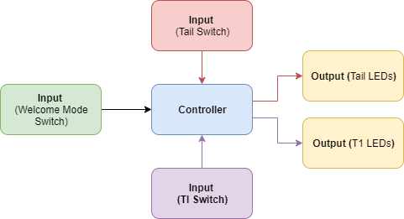

Fig. 1

Pin Layout

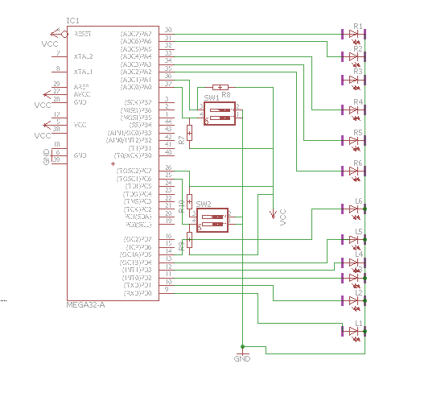

Fig. 2

# Features:

* At launch the LEDs will perform welcome mode.
* Use tail switch to perform tail feature.
* Use TI switch for TI feature.